KO01 – Create Internal Order

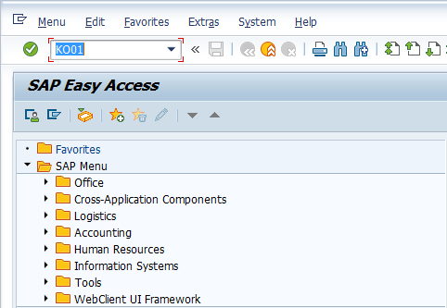

- Input KO01 in Transaction Box and press Enter key

Set Controlling Area Screen.

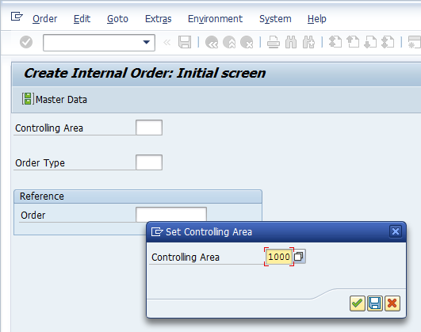

- Controlling Area: Input or select controlling area with the help of F4 key
Press Enter key

Create Internal Order Initial Screen.

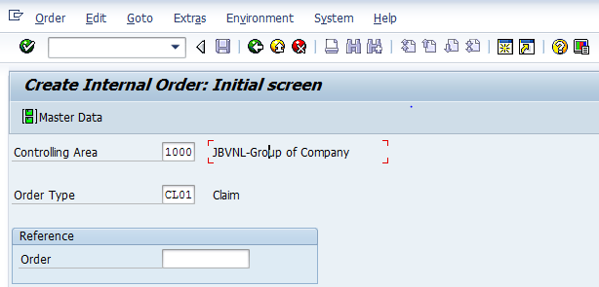

- Order Type: Select order type with the help of F4 key
Press Enter key

Create Internal Order Master Data Screen.

Assignment Tab

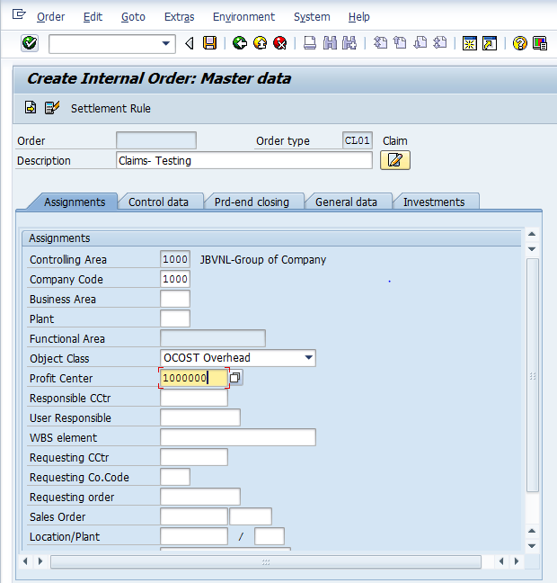

- Description: Input required description
- Company Code: Input relevant company code
- Plant: Input or select plant with the help of F4 key
- Profit Center: Input or select cost center with the help of F4 key
Select Control data tab

Create Internal Order Master Data Screen.

Control data Tab

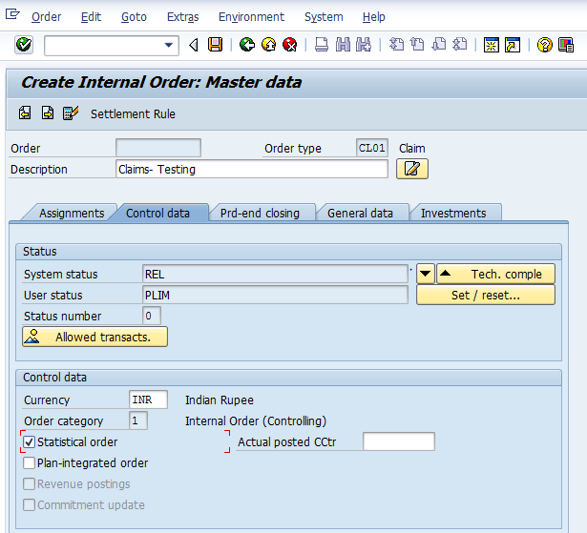

- Currency: Input or select the currency with the help of F4 key
- Statistical Order: Select statistical order
Click on Save icon or press Ctrl+S keys to save the data.

The order was created message appears at bottom of the screen

Manual End

